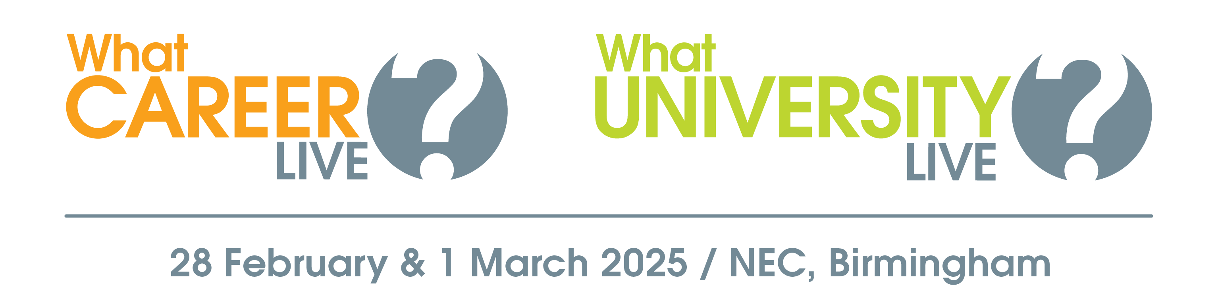

Explore your options at
What University? & What Career? Live!

Dear Student,

University? An apprenticeship? A training course? What will you do next?

What University? & What Career? Live is designed to help you learn more about the full range of options when you leave school or college.

Head to this free event at the NEC, Birmingham, on 28 February & 1 March to:

- Meet representatives from leading universities and employers
- Watch a packed programme of free talks
- Get one-to-one advice from careers advisors & CV experts
- Take part in free skills workshops

More information about the event – including who’s exhibiting and the talk timetable – can be found here >> https://www.whatcareerlive.co.uk/events/birmingham/

Event opening hours:
Friday 28 February: 9:30am – 3pm
Saturday 1 March: 10am – 4pm

Location:
Hall 12, the NEC
North Ave
Marston Green
Birmingham
B40 1NT

Don’t miss this valuable opportunity to gather the inspiration and information you need to take your next steps with confidence!
Note to teachers - remove next sentence if you are organising a group trip.
Book your free ticket today at WhatCareerLive.co.uk.

Kind regards,

