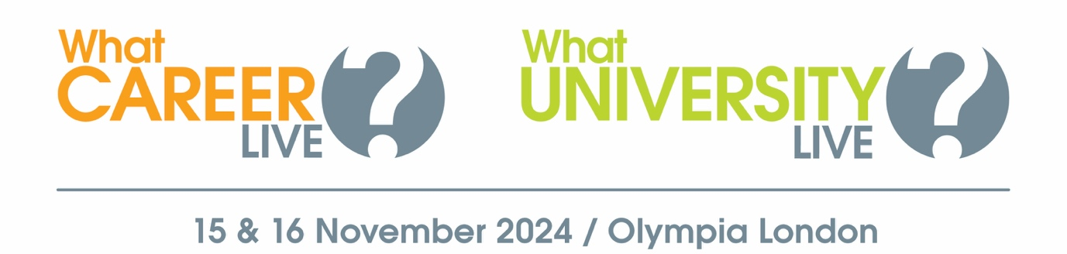

**Explore your options at**

**What University? & What Career? Live!**

Dear Student,

University? An apprenticeship? A training course? What will you do next?

What University? & What Career? Live is designed to help you learn more about the full range of options when you leave school or college.

Head to this free event at Olympia London on 15 & 16 November to:

* Meet representatives from leading universities and employers
* Watch a packed programme of free talks
* Get one-to-one advice from careers advisors & CV experts
* Take part in free skills workshops

More information about the event – including who’s exhibiting and the talk timetable – can be found here >> <https://www.whatcareerlive.co.uk/london-event>

Event opening hours:

Friday 15 November: 9:30am – 3pm

Saturday 16 November: 10am – 4pm

Location:

Olympia London  
Hammersmith Road  
London  
W14 8UX

Don’t miss this valuable opportunity to gather the inspiration and information you need to take your next steps with confidence!

Note to teachers - remove next sentence if you are organising a group trip.

Book your free ticket today at WhatCareerLive.co.uk.

Kind regards,