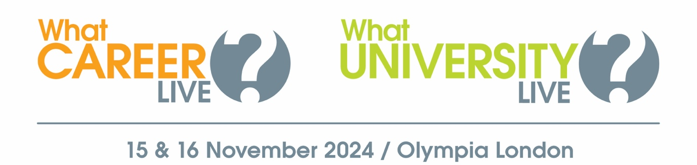

**Give your teenager the opportunity to explore their options at**

**What University? & What Career? Live!**

Dear Parent/Guardian,

What University? & What Career? Live is a free event designed to help students aged 15-19 learn more about their further education and apprenticeship options when they leave school or college.

Taking place at Olympia London on 15 & 16 November, the event offers visitors the chance to:

* Meet representatives from leading universities and employers
* Watch a packed programme of free talks
* Get one-to-one advice from careers advisors & CV experts
* Take part in free skills workshops

More information about the event – including who’s exhibiting and the talk timetable – can be found here >> <https://www.whatcareerlive.co.uk/london-event>

This free event also features a dedicated Parents’ and Advisors’ area, where you can access a wealth of information to help you support your child as they take their next steps.

Book your free tickets here >> <https://www.whatcareerlive.co.uk/book-tickets>

Event opening hours:

Friday 15 November: 9:30am – 3pm

Saturday 16 November: 10am – 4pm

Location:

Olympia London  
Hammersmith Road  
London  
W14 8UX

Don’t miss this valuable opportunity for your teenager to gather the inspiration and information they need to take their next steps with confidence!

Kind regards,