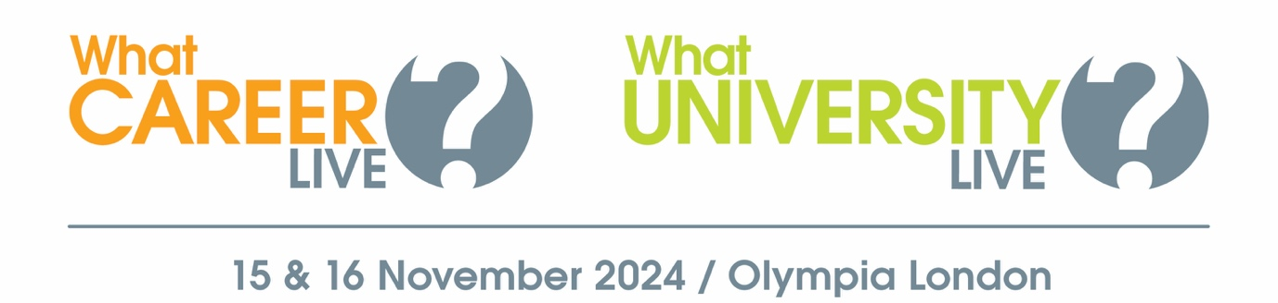

Explore your options at What University? & What Career? Live

On Friday 15 & Saturday 16 November, What University? & What Career? Live opens at Olympia London offering you the opportunity to learn more about your further education and apprenticeship options.

Book your free ticket to:
- Meet representatives from leading universities and employers
- Watch a packed programme of free talks
- Get one-to-one advice from career advisors & CV experts
- Take part in free skills workshops

For more information about what’s going on and who’s exhibiting, or to book your free ticket visit WhatCareerLive.co.uk

