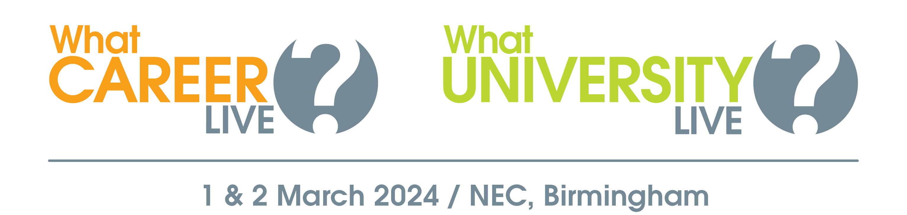

**Explore your options at What University? & What Career? Live**

On Friday 1 & Saturday 2 March, What University? & What Career? Live opens at the NEC, Birmingham offering you the opportunity to learn more about your further education and apprenticeship options.

**Book your free ticket to:**

* Meet representatives from leading universities and employers
* Watch a packed programme of free talks
* Get one-to-one advice from careers advisors & CV experts
* Take part in free skills workshops

For more information about what’s going on and who’s exhibiting, or to book your free ticket visit [WhatCareerLive.co.uk](https://www.whatcareerlive.co.uk/)